
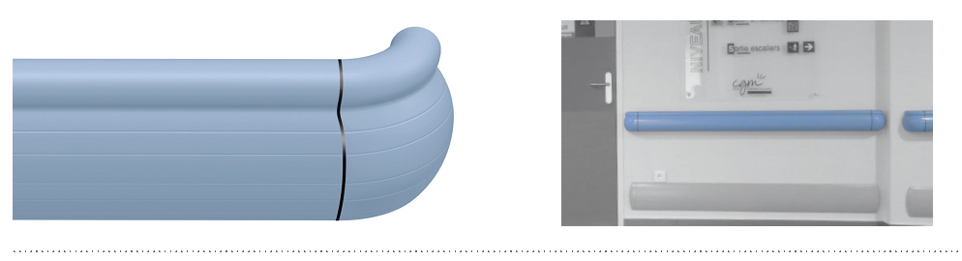


SPECIFICATION

PERFORMER 2
PROTECTION HANDRAIL – 140 MM HIGH

- Description: hand and wall protection rail (Performer 2 as manufactured by SPM) from 3 mm thick smooth and antibacterial PVC achieving Bs2d0 fire rating with solid colour. The 140 mm high system combines a completely smooth tubular upper part (diameter 40 mm) and a lower wall protection rail with decorative grooves. A protective film is specified to minimise cleaning before acceptance. The PVC profile snap-fixes onto a continuous aluminium profile, 2 mm thick, and finish is provided by smooth PVC accessories with decorative grooves (wall returns, 90° external angles). The unit is fitted into a PVC fixing spacer with aluminium clamp. It is fitted with bactericidal joints.
- Environment: no heavy metals and no substance potentially subjected to any REACH restriction are used in its manufacture, nor PBT/BPA. The calcium-zinc thermal stabilisation process is used. The emission level of volatile substance in inside air has been tested according to ISO 16000-6 and is very low (A+) according to the French regulation (23 March 2011 nr 2011-321 Decree and 19 April 2011 Order). 100% of the product are recyclable.
- Colour: selected by architects from manufacturer’s standard range.
- Installation method: upper edge of section 0.90 m max. above floor level. Fixing on PVC spacers to be fitted at 1.20 m centres (0.80 m centres in heavy traffic corridors and on light partitions like plasterboard). Wall returns and external angles fixing with pop rivets.
